

Figure 1. Historical trends in Lake 227. Shading represents fertilization regime. Dotted line represents breakpoint as determined by Pettitt’s test. Color of point indicates direction of trend before or after breakpoint (yellow = significant positive trend, purple = significant negative trend, gray = non-significant trend).



Figure S1. Historical trends in external drivers in the Lake 227 catchment. Panels A-C represent conditions at the meteorological site, and panels D-E represent stream inflow concentrations of TP and DIN. Shading represents fertilization regime. Dotted line represents breakpoint as determined by Pettitt’s test. Color of point indicates direction of trend before or after breakpoint (yellow = significant positive trend, purple = significant negative trend, gray = non-significant trend).



Figure 2. Evaluation of model fit for three periods.

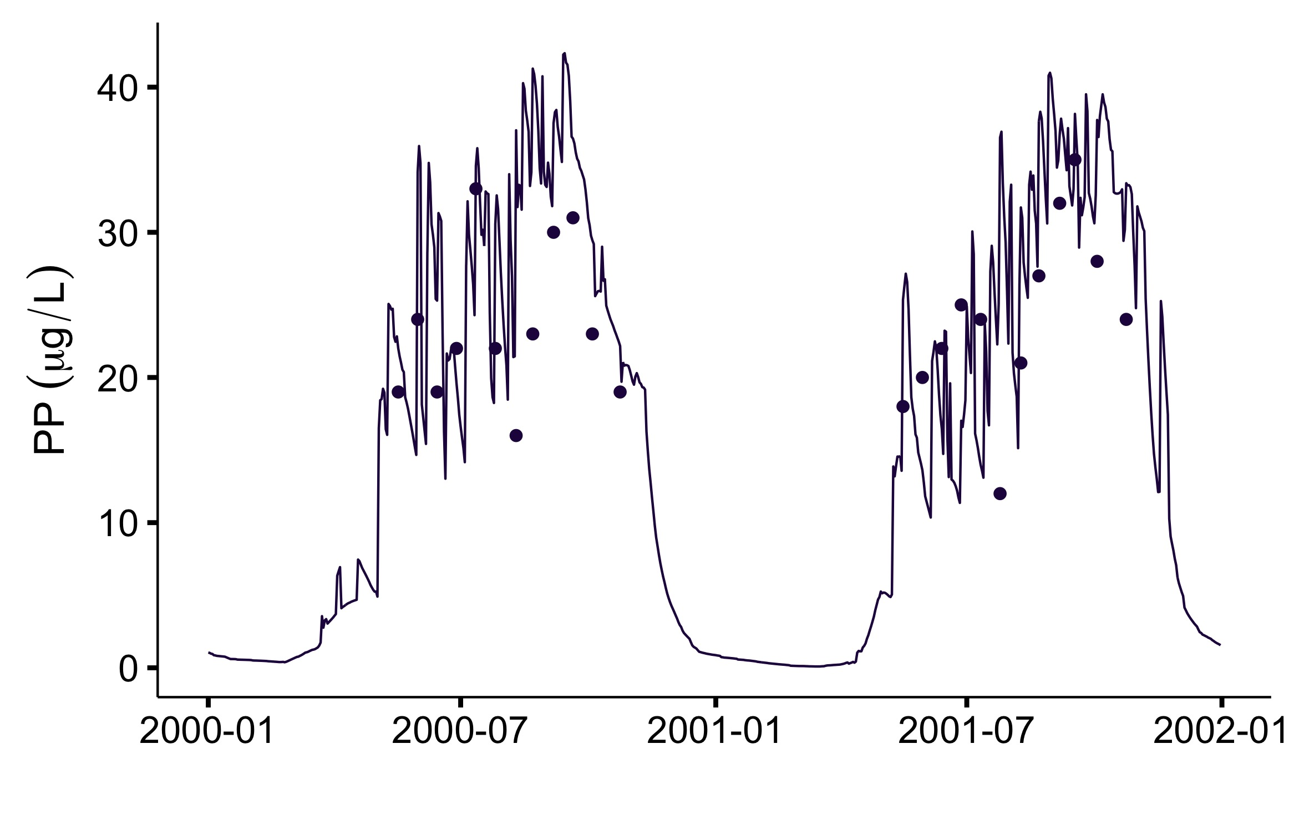



Figure S2. Evaluation of model fit for three periods.

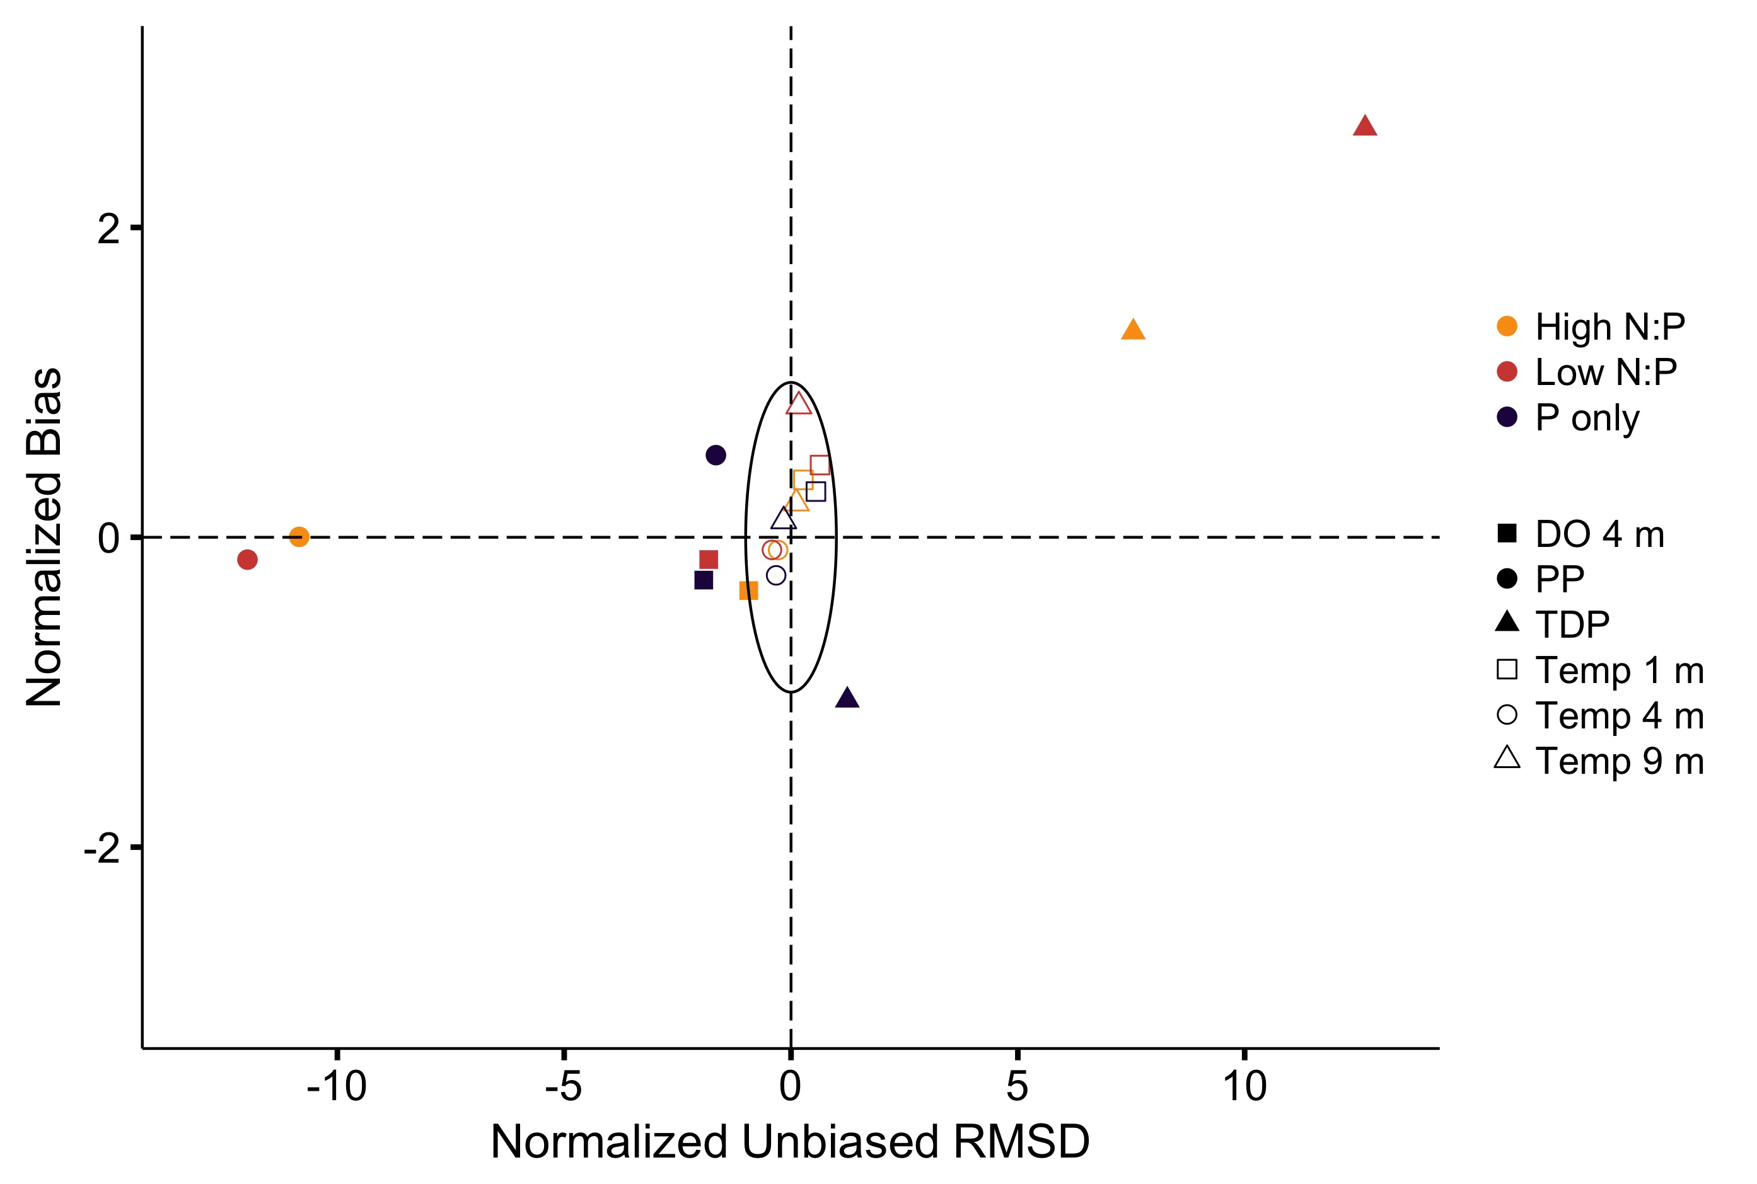Figure 3. Target plot evaluating model fit for three periods.